

**Tribhuvan University**

**Faculty of Humanities and Social Science**

**A PROJECT REPORT**

**“Marketplace”**

***In partial fulfillment of the requirements for the Bachelors in Computer Application***

**Submitted by:**

Student: Pramod Chhetri

TU Reg. No: 6-2-1194-79-2019

**Submitted to:**

Department of Computer Application Lumbini ICT Campus

Under the supervision of

**Er. Mod Nath Acharya**



**Tribhuvan University**

**Faculty of Humanities and Social Science**

**Lumbini ICT College**

**Supervisor’s Recommendation**

I hereby recommend that this project prepared under my supervision by **Pramod Chhetri** entitled “**Marketplace”** in partial fulfillment of the requirements for the degree of Bachelor of Computer Application is recommended for the final evaluation.

-----------------

Er. Mod Nath Acharya

**Supervisor**

Faculty of Humanities and Social Science

Lumbini ICT Campus

Gaindakot, Nawalparasi

i

**Acknowledgement**

Firstly, we would like to express our deep gratitude to the Department of Bachelor in Computer Applications, Lumbini ICT College for providing the necessary resource and guideline to come up with this project. We would like to thank Head of Department and all the concerned faculty member of the department. Our special thanks to supervisor Er. Mod Nath Acharyafor his insightful advice, motivating suggestions, invaluable guidance, help and support in successful completion of this project and also for his constant encouragement and advice throughout our Project Development. We express our deep gratitude to Sudip Parajuli for their regular support, co-operation, and co-ordination. Special thanks also go to all the teaching and non-teaching staff as well as colleagues, who have been assisting in the project directly as well as indirectly by reviewing and suggesting the improvements. Last but not the least, our cordial thank goes to Lumbini ICT College Administration who motivated us to go ahead with this project.

Pramod Chhetri

**Abstract**

With the increasing popularity of online shopping, the traditional way of visiting physical stores has become inconvenient for customers and businesses. The Online Marketplace described in this document has been designed to address this market need by providing a platform for customers to buy a wide range of products online with just a few clicks, without the need to visit multiple stores physically. Additionally, in situations like lockdowns due to viruses like COVID, online marketplaces offer a safer alternative to in-person shopping.

The main objective of this project is to create an online marketplace that allows users to search and purchase products based on various criteria such as product name, category, and seller. The selected products are displayed in a user-friendly format, and users can easily add items to their shopping cart and complete their purchases online. Through a web browser, customers can browse through a diverse range of products, compare prices, and make informed decisions.

The website will allow users to create accounts or log in to their existing accounts for a seamless shopping experience. New customers can quickly set up an account by providing their name, contact information, and shipping address. The platform will categorize products into various categories like Electronics, Fashion, Home & Living, etc., to enhance user navigation and product discovery. The Online Marketplace Website will provide customers with a secure and straightforward online shopping experience. Payment options will be integrated to allow customers to complete transactions electronically. Customers can add products to their carts, proceed to checkout, and make secure payments through various payment gateways.

In addition to common users, the platform will also provide administrative functionalities to registered sellers. Sellers will have the ability to manage their product listings, update product details, and fulfill orders from their own dashboard. The administrator will have further privileges to manage product categories, user information, and oversee the entire marketplace. This application will be developed using a combination of web technologies, including HTML, CSS, JavaScript, Bootstrap, and a robust backend framework like Laravel. The database will be designed using SQL Server to efficiently store product details, user information, and order data. To ensure a seamless and secure experience for users, the platform will prioritize user authentication and data protection. Regular testing and feedback gathering will be performed to identify and fix any issues, ensuring a smooth user experience.

**Table of Contents**

List of Abbreviations vi

List of Figures vii

List of Tables viii

Chapter 1: Introduction 1

1.1 Introduction 1

1.2 Problem of Statement 1

1.3 Objectives 2

1.4 Scope and Limitation 2

1.5 Report Organization 3

Chapter 2: Background Study and Literature Review 4

2.1 Background Study 4

2.2. Literature Review 5

Chapter 3: System Analysis and Design 6

3.1 System Analysis 6

3.1.1. Feasibility Analysis 7

3.1.2 Requirement Elicitation and Analysis 7

3.1.3 Requirements Specification 8

3.1.4 Requirement Validation 9

3.2 System Design 10

3.2.1 Context Model 10

3.2.2 Process Modelling 11

3.2.3 Structural Modeling 12

3.2.4 Dynamic Modeling 13

3.3 Database Design 15

3.3.1 Data Modelling (ER-Diagram) 15

3.3.2 Database Schema Design 16

3.3.3 Interface Design (UI Interface / Interface Structure Diagrams) 17

3.4 Algorithm 23

Chapter 4: Implementation and Testing 24

4.1. Implementation 24

4.1.1. Tools Used 24

4.1.2. Software Requirement 25

4.2. Testing 26

4.2.1. Test Cases for Unit Testing 26

4.2.2 Test Cases for System Testing 29

Chapter 5: Conclusion and Future Recommendations 31

5.1 Lesson Learnt / Outcome 31

5.2 Conclusion 31

5.3 Future Recommendations 31

5.4. Time Plane 32

Chapter 6: Appendix 33

References 38

# List of Abbreviations

SQL: Structured Query Language

CSS: Cascading Stylesheet

SDLC: Software Development Life Cycle

ER-DIAGRAM: Entity relationship diagram

UML: Unified Modeling Language

# List of Figures

Figure 1: Waterfall Model…..................................................................................................... 6

Figure 2: Context Diagram ......................................................................................................10

Figure 3: Login Activity Diagram .......................................................................................... 11

Figure 4: Payment Activity Diagram ...................................................................................... 11

Figure 5: Class Diagram ......................................................................................................... 13

Figure 6: Sequence diagram .................................................................................................... 14

Figure 7: ER-Diagram ............................................................................................................ 15

Figure 8: Database Schema Design ........................................................................................ 16

Figure 9: Landing page ........................................................................................................... 17

Figure 10: User interface ........................................................................................................ 18

Figure 11: Khalti gateway…................................................................................................... 20

Figure 12: Seller Center…... ................................................................................................... 21

Figure 13: Checkout................................................................................................................ 22

Figure 14: Gant Chart ............................................................................................................. 26

Figure 15: Admin Dashboard .................................................................................................. 33

Figure 16: Manage User Page .................................................................................................34

Figure 17: Manage Category ...................................................................................................34

Figure 18: Manage Stock......................................................................................................... 35

Figure 19: Manage Product ..................................................................................................... 35

Figure 20: Role page…….. .....................................................................................................36

Figure 21: Order Page ............................................................................................................. 36

Figure 22: Permissions ........................................................................................................... 37

Figure 22: Profile .................................................................................................................... 37

# List of Tables

Table 1: Functional Requirements ............................................................................................ 9

Table 2: Software Development Requirements ...................................................................... 25

Table 3: Client Software Requirements .................................................................................. 25

Table 4: Server Software Requirements ................................................................................. 25

Table 5: Unit Testing I ............................................................................................................ 26

Table 6: Unit Testing II ........................................................................................................... 26

Table 7: Unit Testing III ......................................................................................................... 27

Table 8: Unit Testing IV ......................................................................................................... 27

Table 9: Unit Testing V .......................................................................................................... 27

Table 10: Unit Testing VI ....................................................................................................... 28

Table 11: Unit Testing VII ...................................................................................................... 28

Table 12: Unit Testing VIII .................................................................................................... 28

Table 13: Unit Testing IX ....................................................................................................... 29 Table 14: System Testing ....................................................................................................... 29

# Chapter 1: Introduction

## 1.1 Introduction

This project, "Online Marketplace" is a comprehensive web system designed to revolutionize the way people shop by enabling them to purchase products online instead of visiting physical stores. The primary goal of the project is to develop a fully functional online marketplace that allows users to effortlessly search and buy a wide range of products based on categories, roles, and subjects. By addressing requirements, use cases, database design, component frameworks, and user interfaces, we aim to create an efficient and collaborative web service application.

The selection of an online marketplace as the focus of this project is driven by the ubiquitous familiarity of people with traditional marketplaces. Our objective is to provide customers with the convenience of shopping for products and other products from the comfort of their homes via the Internet. The website will offer a user-friendly interface where users can easily search for products based on titles, roles, or subjects, and view their search results in a tabular format. Subsequently, customers can place their orders online, streamlining the purchasing process.

In addition to enhancing customer satisfaction by eliminating the need for form filling and direct interactions with customer service representatives during check-in, the platform will also offer exclusive functionalities for administrators. Administrators will have enhanced access to manage products, categories, and user information, enabling them to provide superior service to customers. This improved level of service, coupled with the convenience of online shopping, will foster higher customer loyalty and make the online marketplace a preferred destination for shopping needs.

In conclusion, the Online Marketplace Management System seeks to create a seamless online shopping experience, redefining the traditional marketplace model. By focusing on user-friendly interfaces, efficient search capabilities, and exceptional customer service, this project aims to transform the way people shop, making online purchasing the preferred choice for customers across various domains.

## 1.2 Problem of Statement

In the context of Nepal, the increasing adoption of technology and internet penetration has opened up new opportunities for businesses, including the emergence of online marketplaces Creating an online marketplace in Nepal can be an exciting venture, but it comes with its own set of challenges. Here are some specific considerations and potential problems you might encounter when building an online marketplace in Nepal:

1. Payment Gateways: In Nepal, there might be limited options for online payment gateways, which can make it challenging for customers to make online transactions. Integrating reliable and secure payment gateways might be a challenge.
2. Trust and Security Concerns: Online marketplaces rely on trust between buyers and sellers. In Nepal, some customers may be hesitant to make online purchases due to security concerns or a lack of confidence in the online marketplace ecosystem.
3. Marketing and Awareness: Building brand awareness and attracting customers to a new online marketplace can be a significant challenge. Implementing effective marketing strategies tailored to the Nepali audience is crucial.
4. Customer Support: Providing excellent customer support is essential for building trust and retaining customers. Ensuring prompt and efficient customer service might be a challenge, especially during peak times.

## 1.3 Objectives

The general objectives of the system are to develop a reliable, convenient and accurate marketplace. The main objectives of designing this program are:

1. The main objective of the project to establish an online marketplace for buyers and sellers to connect and conduct transactions.
2. Improve user experience by providing a user-friendly interface and navigation.
3. Ensure a secure and reliable payment gateway for seamless transactions.
4. Offer a diverse range of products and services to cater to different customer needs.
5. Provide effective customer support to address queries and concerns promptly.
6. Facilitate seller onboarding and product listing process for smooth operations.

## 1.4 Scope and Limitation

Online marketplace offers a convenient way to explore and purchase products while enjoying cost savings. The project aims to provide various facilities found in an online productstore, helping people access products affordably. This system efficiently handles customer queries about different product attributes, such as roles, permissions, titles, prices, updates, and storage information. However, there are limitations to consider, including vulnerability to cyber hacks, high costs, dependence on the internet, limited product availability, potential errors in user queries, and inability to generate offline reports due to batch processing.

**Limitation:**

* Limited personal interaction with sellers, impacting the ability to negotiate or get immediate responses to queries.
* Shipping delays or issues can affect the timely delivery of products.
* Potential technical glitches or downtime that can disrupt the shopping experience.
* Inability to inspect products physically before purchase, which may lead to buyer dissatisfaction.
* Difficulty in returning or exchanging products, depending on the marketplace's policies.
* Possibility of fraudulent sellers or products, necessitating caution from buyers.

## 1.5 Report Organization

This report is organized in five chapters, as indicated in the Table of Contents. These chapters deal with the important aspects of the Systems Development Life Cycle. Each of the chapters is divided into Headings and Sub-Headings. Chapter 1 introduces the project, its objectives and scopes. The background study and literature review are explained in Chapter 2. Chapter 3 broadly deals with the requirements, analysis and design. Chapter 4 includes the implementation and testing of the system. The test reports and testing of the working of the system is discussed here. Chapter 5 deals with the conclusion and recommendations of the system. At the end of the report, the references made the glossary along with appendices have been included.

# Chapter 2: Background Study and Literature Review

## 2.1 Background Study

Online marketplace in Nepal is a virtual platform that facilitates seamless transactions between buyers and sellers, enabling them to trade products and services with ease. It leverages the power of the internet to connect businesses and consumers, offering a wide array of products from various sellers, while providing customers with the convenience of shopping from the comfort of their homes. Through the online marketplace, businesses can expand their reach, tap into new markets, and increase their visibility. Moreover, it fosters healthy competition, encourages innovation, and promotes economic growth within Nepal's digital landscape. With its user-friendly interface and secure payment gateways, the online marketplace ensures a safe and enjoyable shopping experience for all users. Whether it's fashion, electronics, home essentials, or local artisan products, the online marketplace caters to the diverse needs and preferences of Nepali consumers, making it an indispensable platform for modern commerce in Nepal.

Some of the existing popular online marketplaces in Nepal include:

* Daraz Nepal (www.daraz.com.np): One of the largest e-commerce platforms in Nepal, offering a wide range of products, from electronics and fashion to home appliances and more. It provides both local and international sellers.
* SastoDeal (www.sastodeal.com): A prominent online shopping platform that features discounted deals on electronics, fashion, home goods, and more. It has gained popularity for its exclusive offers and daily deals.
* HamroBazar (www.hamrobazar.com): A classifieds-based marketplace that allows individuals and businesses to buy and sell new or used items, including vehicles, electronics, furniture, and real estat4e.
* NepBay (www.nepbay.com): An e-commerce platform that facilitates online shopping for electronics, fashion, home appliances, and various other categories.

## 2.2. Literature Review

A lot of websites and applications can be found when we search the google which are developed for learning purposes. But there is ambiguity in choosing the appropriate content in appropriate time. Some websites have been developed which consists of stories, novels, essays etc. Similarly, some personal blogs and websites are developed for studying purpose. Electronic Commerce (e-commerce) applications support the interaction between different parties participating in a commerce transaction via the Shop new, used, rare and out-of-print products. Literature review for online marketplace prototype provides a guideline in developing a real system of online marketplace based on user's perspective, particularly in the perspective of academic will be handled by the university's product store. However, the ordering is still done manually. Online marketplace is web-based application designed to record related information about products and their selling’s. By previous research of the online product stores webpage/website, some limitations were found. Limitations like there has been use of older version of programming language, unsystematic users’ interface, and unadvanced search options. Hence to overcome those limitations this system is designed.

# Chapter 3: System Analysis and Design

## 3.1 System Analysis

This project was initiated following the principles of the Waterfall model, which is a linear and sequential approach to the software development life cycle (SDLC). This model emphasizes completing each task before moving on to the next, ensuring a logical progression of steps. After establishing the project's aims and objectives, I successfully achieved the required goals by employing both qualitative and quantitative analysis.

The Waterfall model proved suitable for this project due to its fixed structure and progress path for design and development. With a clear plan in place, it allowed for effective coordination between various modules, enabling them to work together seamlessly. This approach is particularly well-suited for small projects, especially those with milestones and data-focused patterns, as it facilitates a swift and streamlined life cycle, perfect for quick revisions, early launch, and smooth deployment. By following the Waterfall model, I ensured that the Online Marketplace was developed efficiently, meeting the specified requirements and objectives.

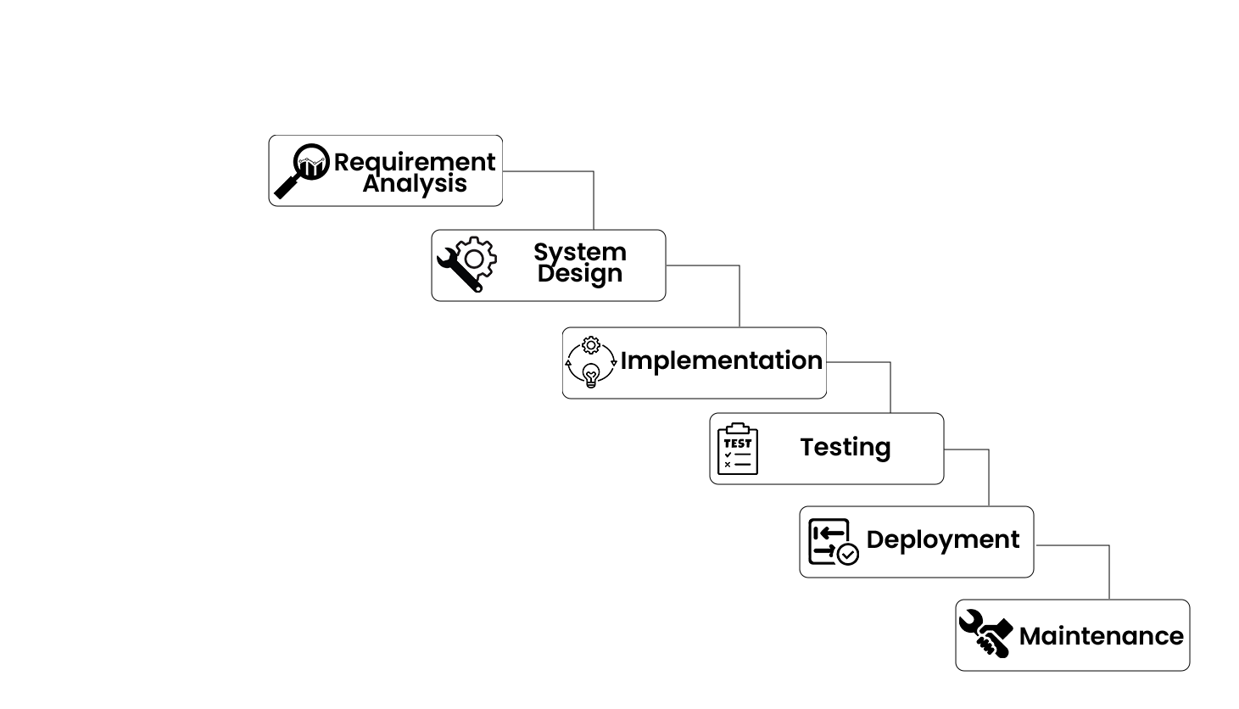

Figure 1: Waterfall Model

### 3.1.1. Feasibility Analysis

#### i. Technical Feasibility

This is technically feasible as it can be developed easily with the help of available technology like HTML, CSS, PHP, Bootstrap etc. Development team are technical skill and capabilities. The technology we use is stable and established.

#### ii. Operational Feasibility

This is operationally feasible because system interface is standard, user friendly and provides extensive help. Hence, no special training is required.

#### iii. Economic Feasibility

This is economically feasible because organization does not need to spend much money for the development of this system. The only thing is to be done is making an environment for the development.

#### iv. Schedule Feasibility

A work schedule includes the days of the week and times of the day a particular employee is scheduled to work at a job. The traditional full-time work week in the project involves 4–6-hour days

### 3.1.2 Requirement Elicitation and Analysis

In this phase, we studied the site requirements of the system. We performed the review on the existing software’s and conduct the open interview with the possible users of the system. We conducted an interview on the involved in online product store management system to have a better understanding on how the current system works. We identity that system should include:

* User Registration: Allow customers to register on the platform to access marketplace features.
* User Login: Authenticated users can log in using their registered credentials.
* Admin Login: Administrators can access the dashboard with their designated login credentials.
* Product Listing: Sellers can add and manage products for sale, including product descriptions and prices.
* Shopping Cart: Logged-in users can add products to their cart for a streamlined checkout process.
* Product Display: All products are showcased with relevant details and prices.
* Order Management: Users can review and manage their orders before submission.
* Payment Processing: Secure payment gateways are integrated to facilitate smooth transactions.
* Delivery Details: Users can provide delivery information for successful order fulfillment.
* Order Confirmation: The system generates order confirmations upon successful transactions.
* Customer Support: Provide efficient customer support to address queries and concerns.
* Seller Dashboard: A dedicated interface for sellers to manage their products and sales.
* Product Reviews: Allow users to leave feedback and reviews on purchased products.
* Logout: Users can safely log out after completing their transactions and activities on the platform.

After identifying all the requirement and problem encountered in the current system, we analyzed the system for design. We made some necessary recommendation on what should done to improve to current state of enrollment.

### 3.1.3 Requirements Specification

After the review on the existing software’s and conduct the open interview with the possible users of the system. I have gathered the requirement and specified those requirements from where we have identified functional and non-functional requirement.

**i. Functional Requirements**

Functional requirements capture the intended behavior of system. This behavior may be expressed as services, tasks or functions the system is required to perform. Use case diagrams are used to describe the functional requirements as they represent the system’s functions.

* Admin:In this module, admin can add, update & delete the users and view the products details.
* User:In this module, customers can view the products, search products, order products.

Table 1: Functional Requirements

|  |  |
| --- | --- |
| User Module | Admin Module |
| * Login/Register * Homepage * Add product * View item * Add to cart * Select quantity * Checkout * View/Edit profile * Billing * Payment * View order * Logout | * Login/Register * View/Edit profile * Manage category * Manage role * Manage permission * Manage order * Manage product * Logout |

#### ii. Non-Functional Requirements

* **Usability:** The system must fulfill its own objectives. It is important to ensure that every function is meaningful to the system.
* **Responsiveness:** The system must respond every request from the user in very few seconds in order to decrease the waiting time.
* **Reliability:** The system should be reliable all the time. The functions in the system should produce the correct output to the user.

### 3.1.4 Requirement Validation

For validation we take the review from both supervisor and client for checking the requirements for validity, consistency, completeness, realism and verifiability. We conducted the open interview for validating the review of the existing system and collected the additional missing information.

## 3.2 System Design

System design is the process of defining the architecture, components, modules, interfaces and data for a system to satisfy specified requirements. Design of the system brings down the knowledge of requirements and analysis to design the software product. Generally, this chapter deals with the module, database design, user interface design and the program design. For the designing of the application, various diagrams like use case diagram, schema diagram, DFD etc. have been used.

### 3.2.1 Context Model

The use case diagram are usually referred to as behavior diagram used to describe the actions of all user in a system. All user describe in use case are actors and the functionality as action of system.

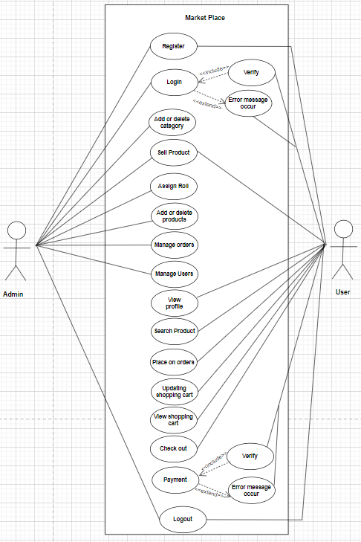

Figure 2: Context Diagram

### 3.2.2 Process Modelling

Process modelling is used to describe how things must/should/could be done in contrast to the process itself which is really what happens. A process model is roughly an anticipation of what the process will look like. The process modelling of the application is done through activity diagrams [5].

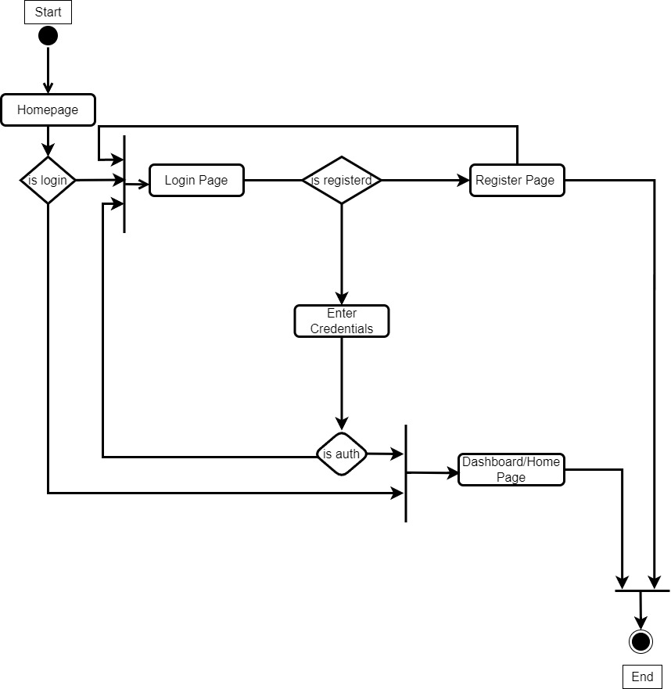

Figure 3: Login Activity Diagram

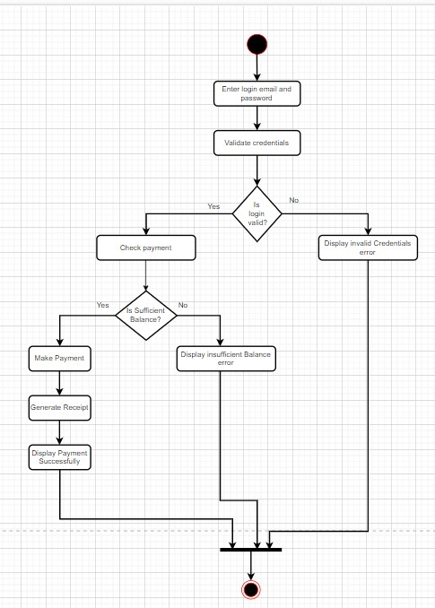

Figure 4: Payment Activity Diagram

### 3.2.3 Structural Modeling

The structural model consists of the objects in the system and the static relationships that exist between them. Groups of objects can be partitioned into packages or subsystems. Class diagrams define the structural model.

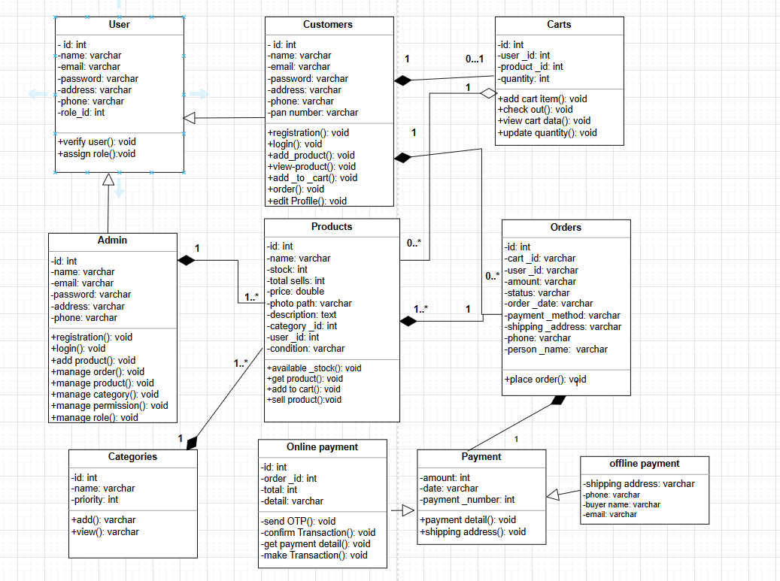

Figure 5: Class Diagram

### 3.2.4 Dynamic Modeling

A sequence diagram consists of a group of objects that are represented by lifelines, and the messages that they exchange over time during the interaction. A sequence diagram shows the sequence of messages passed between objects. Sequence diagrams can also show the control structures between objects.

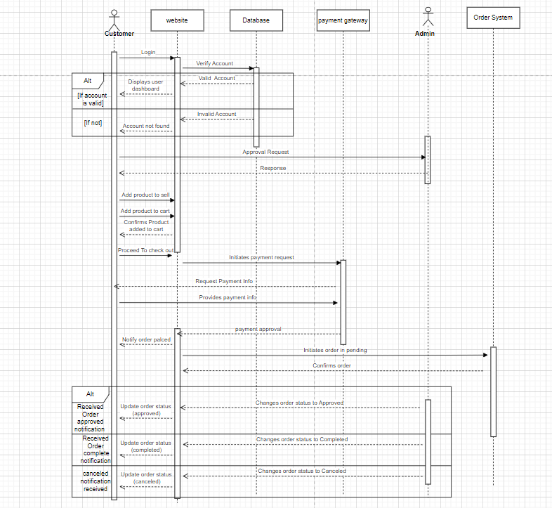

Figure 6: Sequence diagram

## 3.3 Database Design

Database design is a collection of steps that help create, implement, and maintain a business's data management systems. The primary purpose of designing a database is to produce physical and logical models of designs for the proposed database system.

### 3.3.1 Data Modelling (ER-Diagram)

An entity relationship model is a graphical representation of entities and their relationships to each other, typically used in computing in regard to the organization of data within databases or information systems. An entity is a piece of data, an object or concept about which data is stored and a relationship is how the data is shared between entities [3].

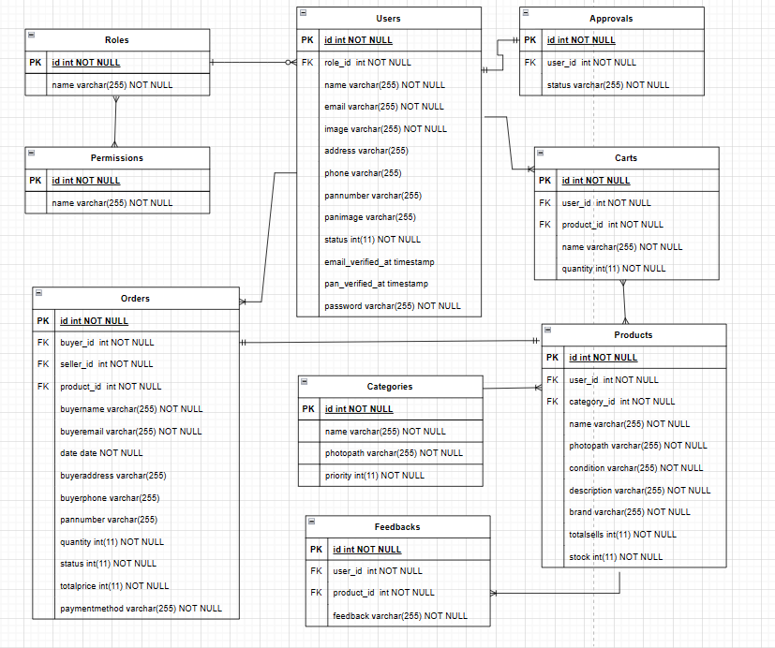

Figure 7: ER-Diagram

### 3.3.2 Database Schema Design

Database schema design organizes the data into separate entities, determines how to create relationships between organized entities, and how to apply the constraints on the data.

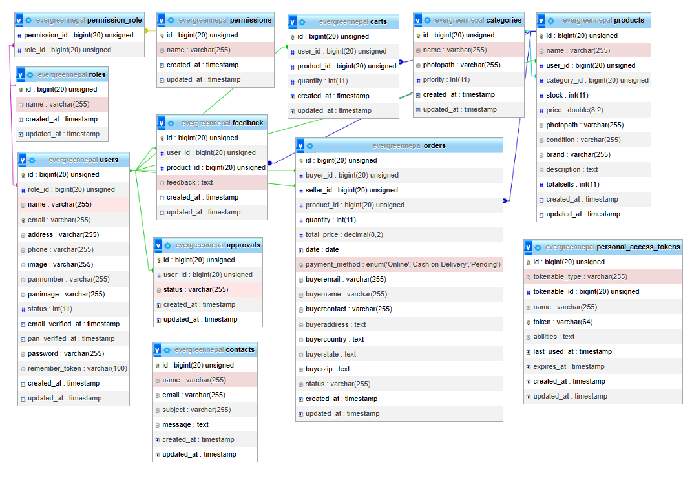

Figure 8: Database Schema Design

### 3.3.3 Interface Design (UI Interface / Interface Structure Diagrams)

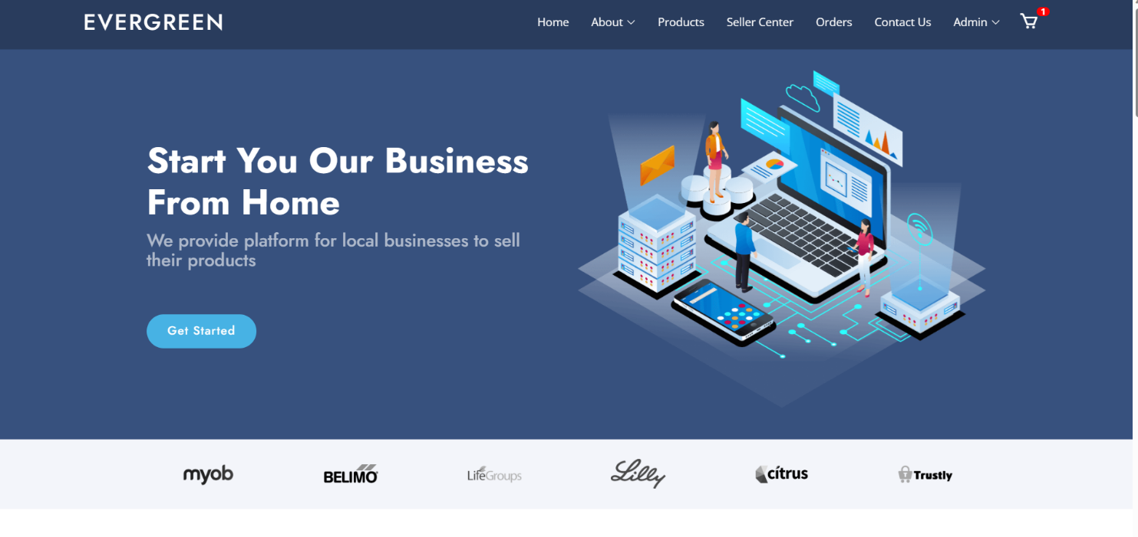

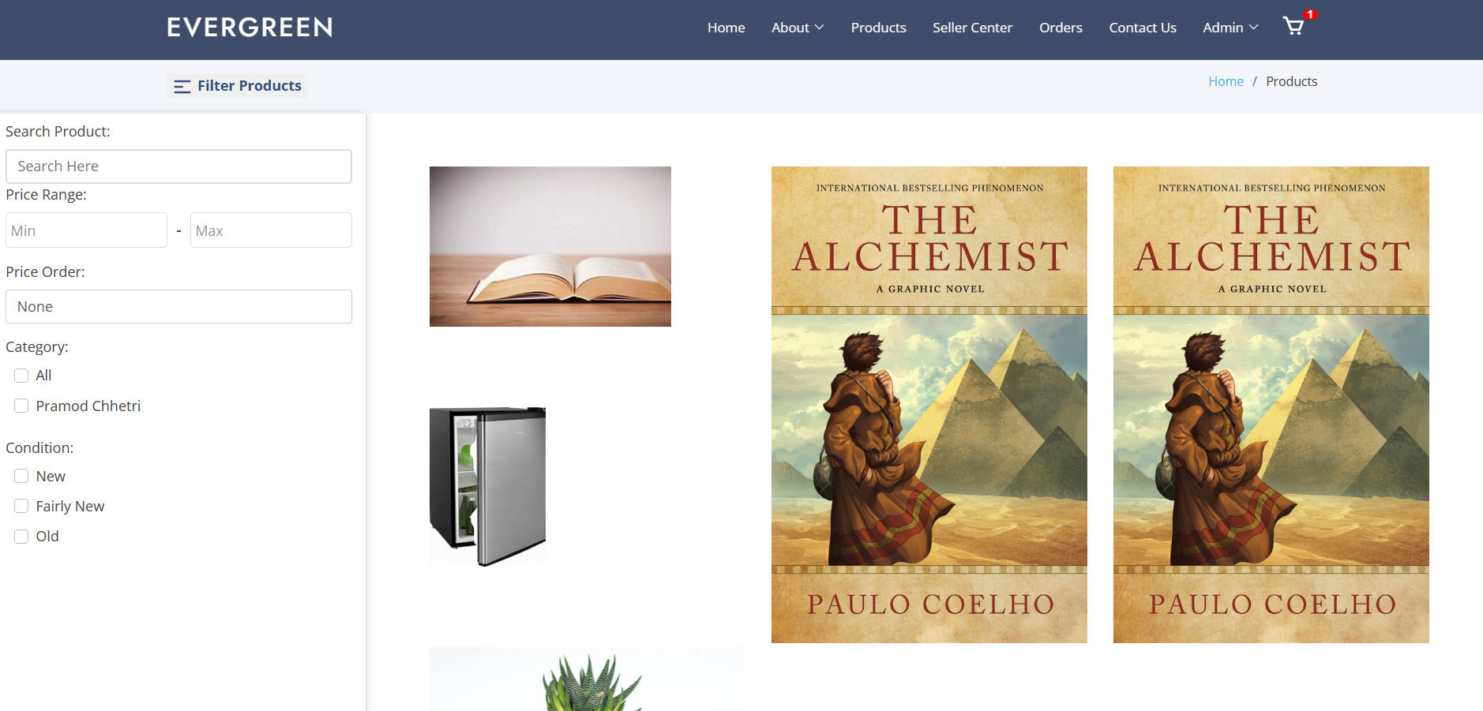

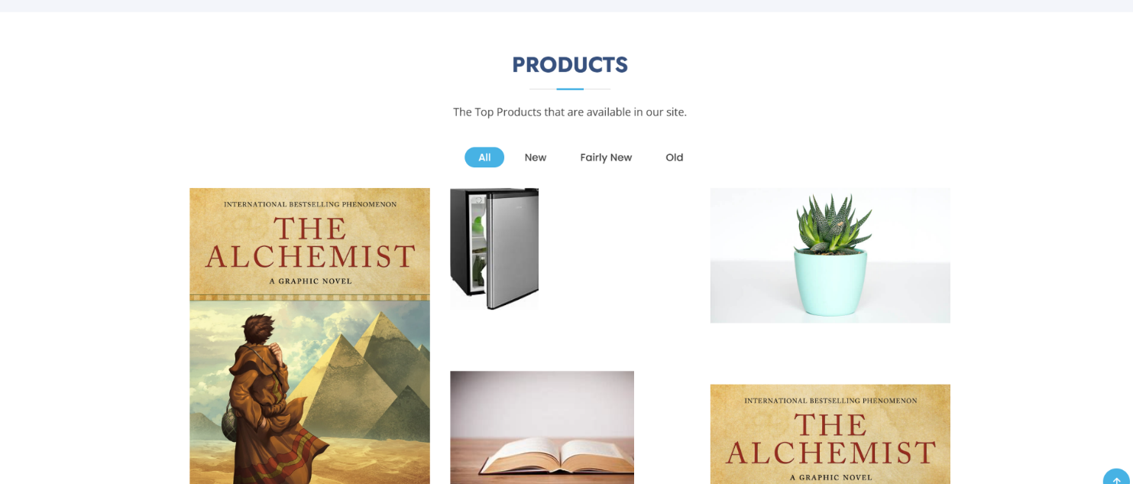

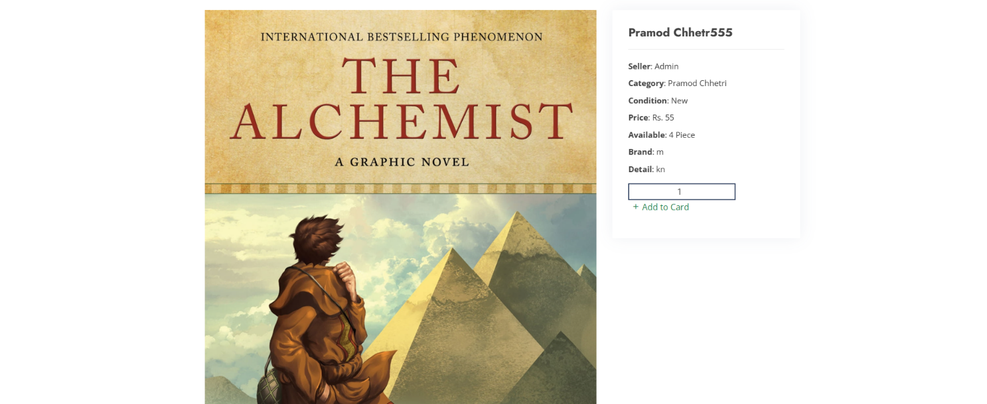

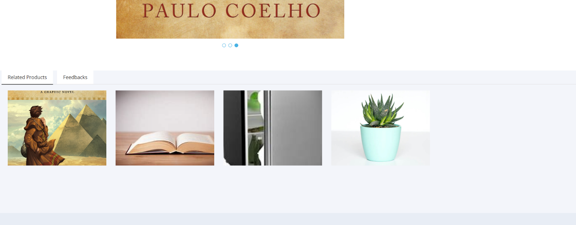

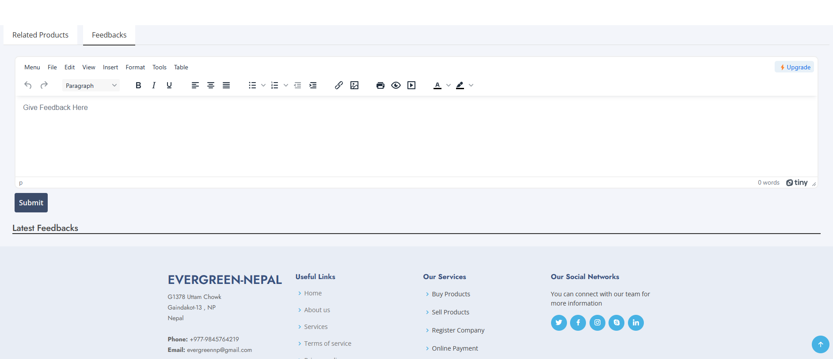

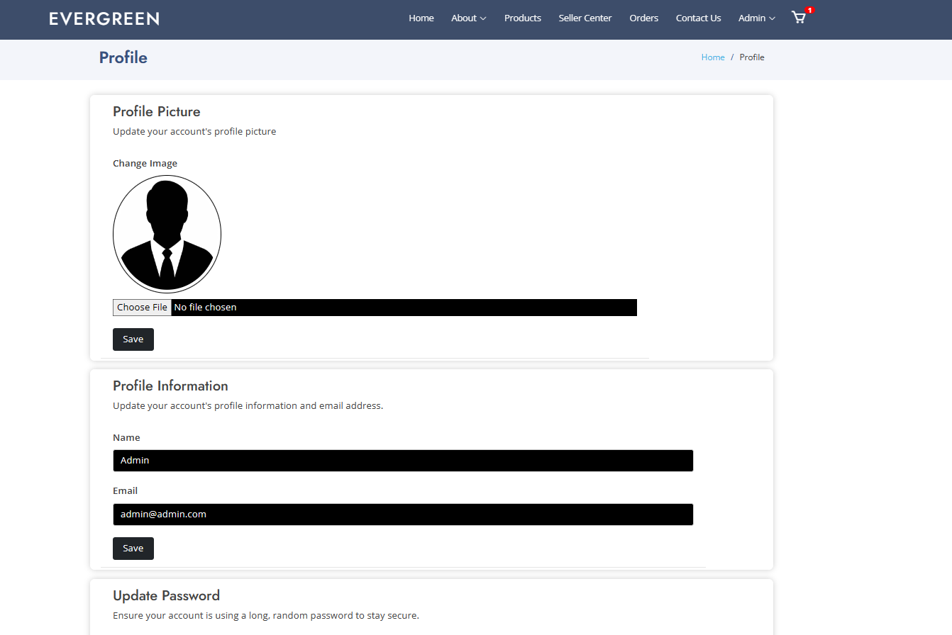

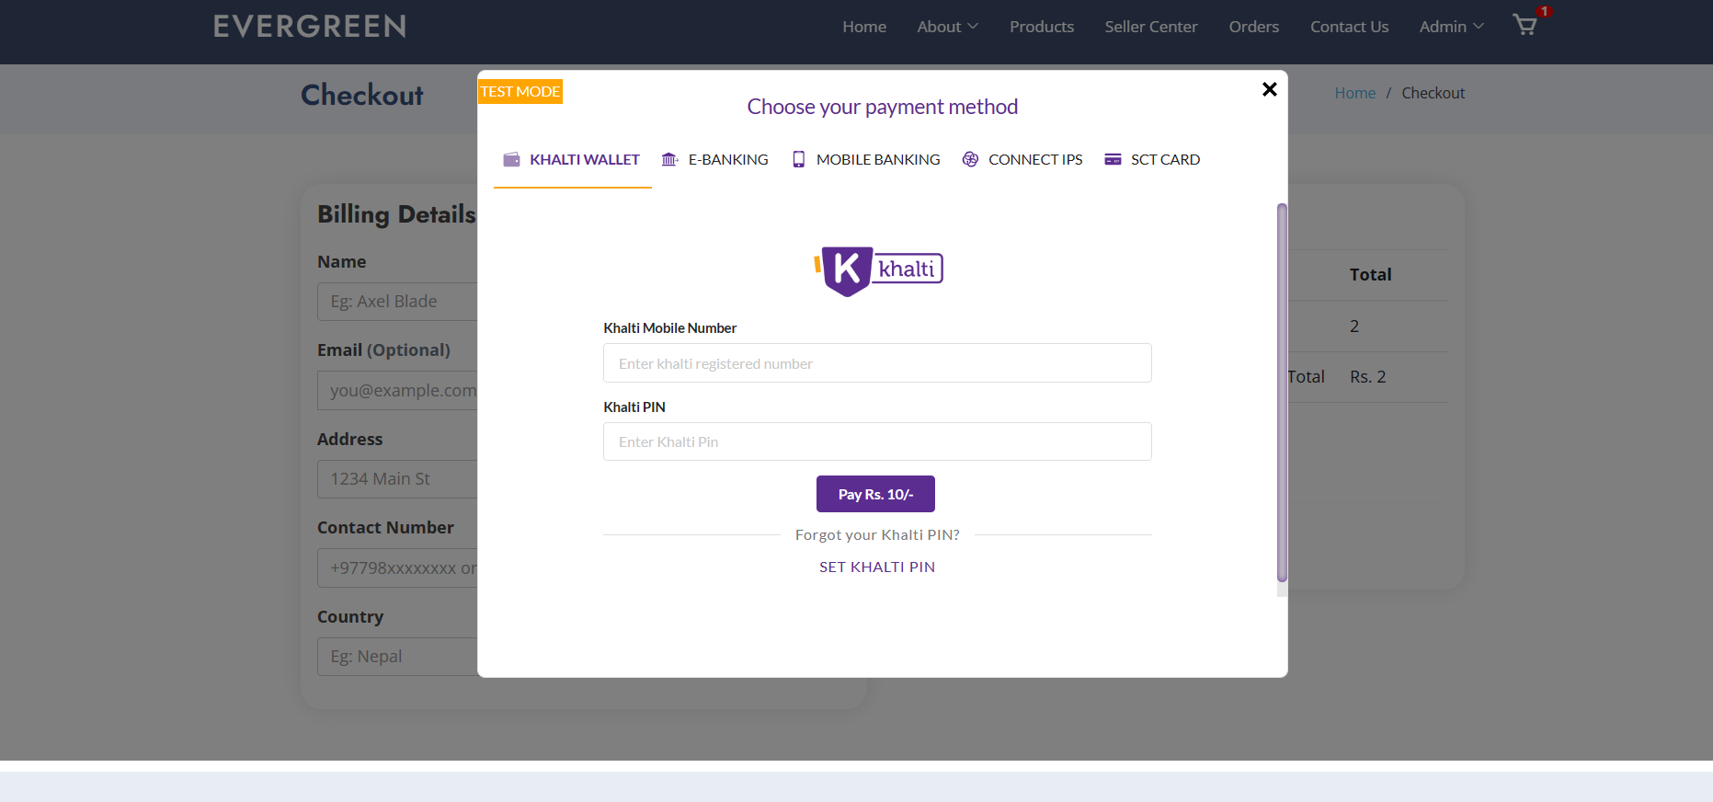

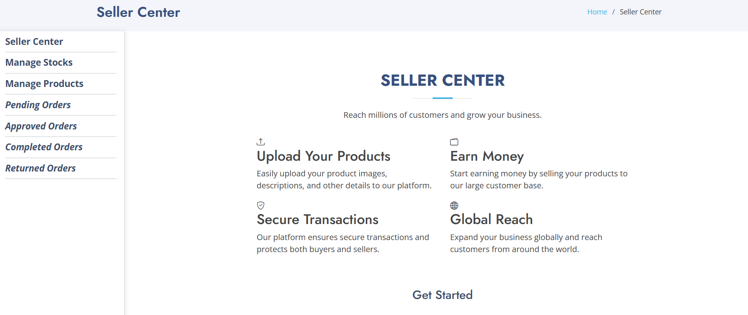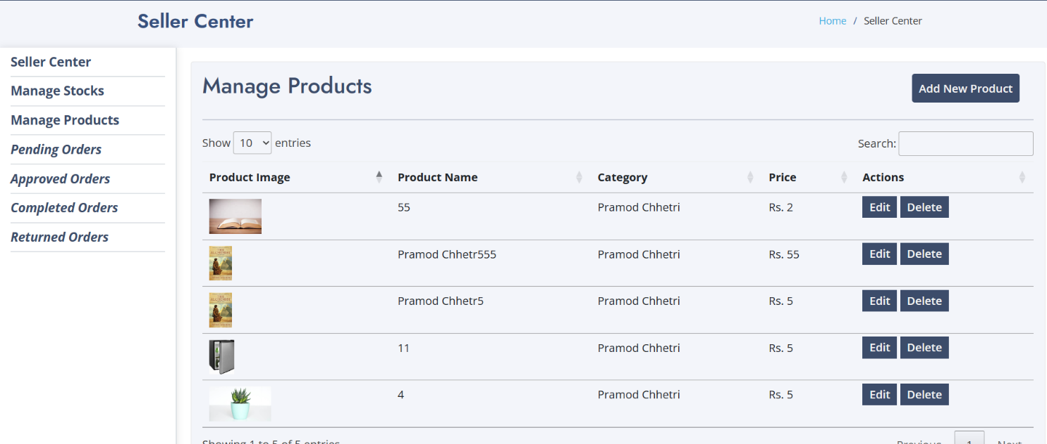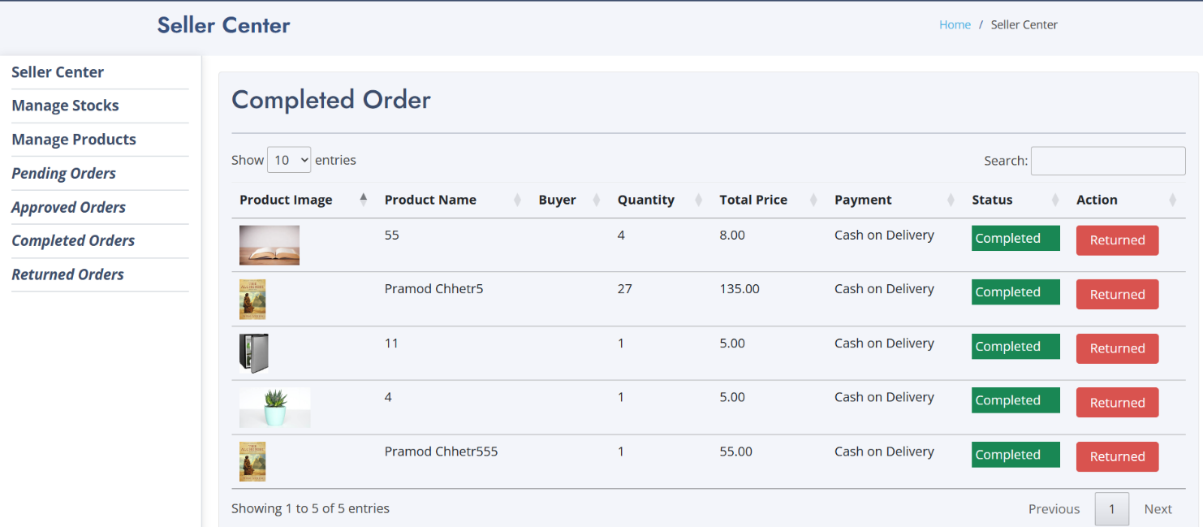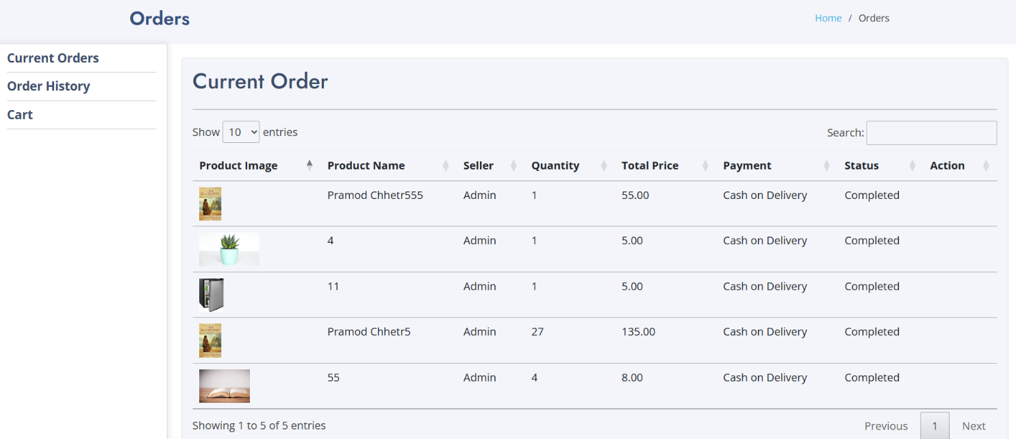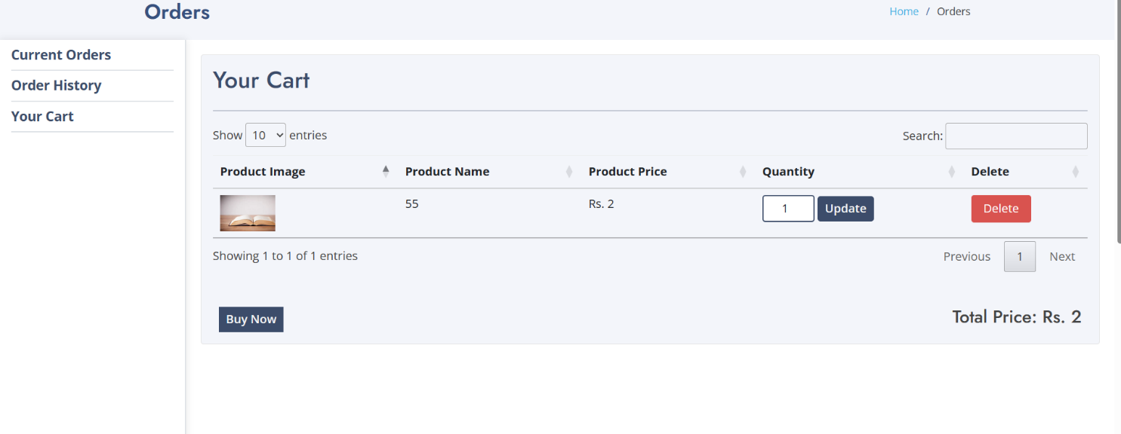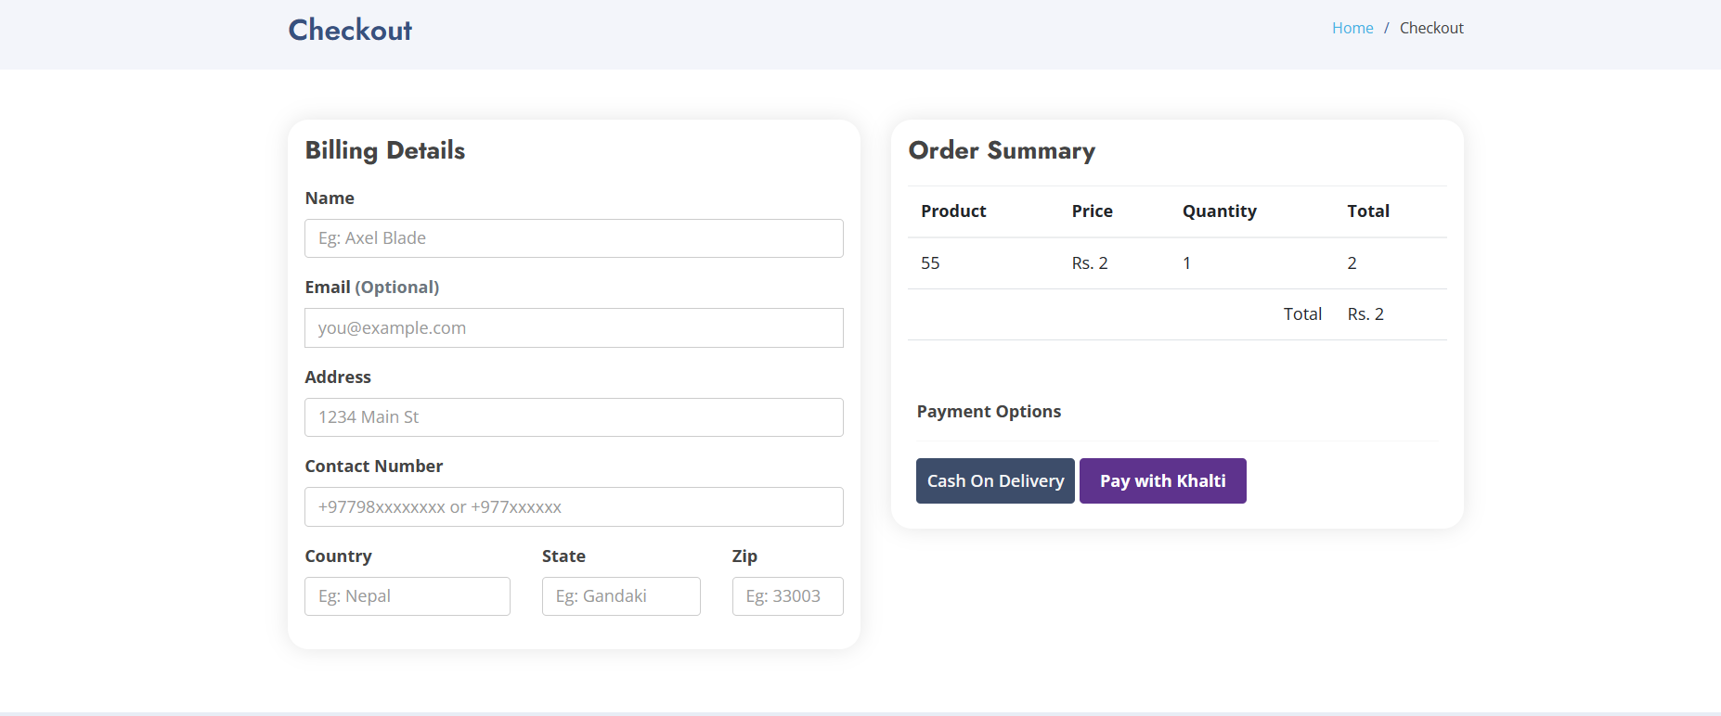

## 3.4 Algorithm

Algorithm: Bubble sort

Input: Product totalsells

Output: Top six products

1. Initialize variables:

* Initialize $itemincart variable to store products in the cart.
* Retrieve all users from the database and store them in the $users variable.
* Retrieve all products from the database and store them in the $products variable.

1. Get all products from the database and store them in the $topsixproducts variable.
2. Sort the products using Bubble Sort based on the 'totalsells' column:
3. Get the number of products (n).
4. Iterate i from 0 to n - 1:

- Iterate j from 0 to n - i - 2:

If the totalsells of the product at index j is smaller than the totalsells of the next product (at index j + 1):

- Swap the positions of the products at index j and j + 1.

4. Paginate the sorted products and store them in the $topsixproducts variable:

1. Get the desired number of products to display per page (perPage).
2. Get the current page number from the request (currentPage).
3. Slice the collection of sorted products to get the products for the current page.
4. Create a LengthAwarePaginator object using the sliced products, total product count, perPage, and currentPage.

5. Retrieve categories ordered by priority and store them in the $categories variable.

6. Return a view called 'frontend.index', passing the following variables to the view:

* $topsixtproducts: Paginated top six products based on sales.

7. End Algorithm.

# Chapter 4: Implementation and Testing

## 4.1. Implementation

During the software implementation phase, each module of software is thoroughly tested for bugs and for accuracy of output. The implementation phase normally ends with the formal test involving all the components.

### 4.1.1. Tools Used

#### • Draw.io

Draw.io is a free online diagram editor built around Google Drive that enables you to create flowcharts, UML, entity relation, network diagrams and more. ER diagram, schema diagrams, use case diagram, activity diagram and DFD are all made using these online tools.

#### • HTML and CSS

Html and CSS are both the core technologies for building web pages. Html provides the structure of the page where CSS provides the layout for various devices.

#### • Bootstrap

It is a framework of CSS that enables developers and designers to quickly build fully responsive websites. It saves you from writing lots of CSS code, giving you more time to spend on designing webpage.

#### • Laravel

Laravel is an open-source PHP framework, which is robust and easy to understand. It follows a model-view-controller design pattern. Laravel reuses the existing components of different frameworks which helps in creating a web application. The web application thus designed is more structured and pragmatic.

#### • MySQL

MYSQL is a powerful open-source database server built based on a relational database management system (RDBMS) and is capable of handling a large concurrent database connection. When combined together, talented PHP and MYSQL developers 20 can build very powerful and scalable Web / Internet / Intranet Applications. Laravel and MYSQL are referred to as development tools.

#### • XAMPP Server

XAMPP is a free and open-source cross-platform web server solution stack package developed by Apache Friends, consisting mainly of the Apache HTTP Server, Maria DB database, and interpreters for scripts written in the PHP and Perl programming languages. Since most actual web server deployments use the same components as XAMPP, it makes transitioning from a local test server to a live server possible.

### 4.1.2. Software Requirement

#### Client (User side)

In a client server system, the server is a relatively large computer in a central location that manages a resource used by many people. Then individuals need to use the resource, they connect over the network from their computers, or clients to the server. **Development Side**

Table 2: Software Development Requirements

|  |  |
| --- | --- |
| Operating System | Windows 7,8,10 |
| Database server | MySQL |
| Programming language | HTML, CSS, JS,PHP,  Laravel |

#### Client Side

Table 3: Client Software Requirements

|  |  |
| --- | --- |
| Browsers | Mozilla, Chrome, MS edge |

#### Server Side

Table 4: Server Software Requirements

|  |  |
| --- | --- |
| Operating System | Windows |
| Web Server | Apache Sever |
| Database | MySQL Server |

## 4.2. Testing

A test plan is a document describing the scope, approach, resources, and schedule of intended testing activities.

### 4.2.1. Test Cases for Unit Testing

Unit Testing was done to test field’s validations, navigation, functionality of the programs and its blocks. These tests are applied on various functions within each program and other critical program blocks.

#### Registration

Table 5: Unit Testing I

|  |  |  |  |  |
| --- | --- | --- | --- | --- |
| ID TEST CASE | | USER INPUT RESULT PASS CRITERIA | | |
| 1 | User/Admin Registration | User/Admin selects already  existing user name | PASSED | Display message to choose different user name |
| 2 | User/Admin  Registration | User/Admin enters different password in password confirm field | PASSED | Display message that  Password and Confirm Password fields don't  match |
| 3 | User/Admin Registration | User/Admin forgets to enter particular required fields | PASSED | Display message The value in field is required |
| 4 | User/Admin  Registration | User/Admin enters all the  details successfully | PASSED | User account created |

#### Login

Table 6: Unit Testing II

|  |  |  |  |  |
| --- | --- | --- | --- | --- |
|  | | | | |
| ID TEST CASE USER INPUT RESULT PASS CRITERIA | | | | |
| 1 | User Login | User enters a wrong username | PASSED | Display message Login or Password is incorrect. |
| 2 | User Login | User enters a wrong password | PASSED | Display message Login or Password is incorrect. |
| 3 | User Login | User enters correct username and password | PASSED | User logs in successfully |

#### Add to Cart

Table 7: Unit Testing III

|  |  |  |  |  |
| --- | --- | --- | --- | --- |
| ID TEST CASE USER INPUT RESULT PASS CRITERIA | | | | |
| 1 | Add to Cart | User selects a product and  clicks add to cart button | PASSED | Product is added to the shopping cart |
| 2 | Add to Cart | Guest selects a product and clicks add to cart button | PASSED | User should create an account. |

#### Edit Cart

Table 8: Unit Testing IV

|  |  |  |  |  |
| --- | --- | --- | --- | --- |
| ID TEST CASE USER INPUT RESULT | | | | PASS CRITERIA |
| 1 | Edit Cart | User changes the Quantity | PASSED | Quantity and total cost of Cart should be updated |
| 2 | Edit Cart | User deletes a product from shopping Cart | PASSED | Products and total cost of Cart should be updated |
| 3 | Edit Cart | User selects a new product to shopping Cart | PASSED | Products and total cost of Cart should be updated |

#### Create, Edit and Delete a Product

Table 9: Unit Testing V

|  |  |  |  |  |
| --- | --- | --- | --- | --- |
| ID TEST CASE ADMIN INPUT RESULT PASS CRITERIA | | | | |
| 1 | Create, Edit and Delete a product | Admin adds a new product | PASSED | Product should be updated |
| 2 | Create, Edit and  Delete a  Product | Admin deletes a product | PASSED | Product should be deleted |

#### Create, Edit and Delete a Category

Table 10: Unit Testing VI

|  |  |  |  |  |
| --- | --- | --- | --- | --- |
| ID TEST CASE ADMIN INPUT | | | RESULTS PASS CRITERIA | |
| 1 | Create, Edit and  Delete a Category | Admin adds a new category | PASSED | Category should be updated |
| 2 | Create, Edit and  Delete a Category | Admin deletes a category | PASSED | Category should be deleted |

#### Create, Edit and Delete an Role

Table 11: Unit Testing VII

|  |  |  |  |  |
| --- | --- | --- | --- | --- |
| ID TEST CASE ADMIN INPUT | | | RESULTS PASS CRITERIA | |
| 1 | Create, Edit and  Delete an Role | Admin adds a new Role | PASSED | Role should be updated to system |
| 2 | Create, Edit and  Delete an Role | Admin deletes Role | PASSED | Role should delete from system |

#### Create, Edit and Delete a permission

Table 12: Unit Testing VIII

|  |  |  |  |  |
| --- | --- | --- | --- | --- |
| ID TEST CASE ADMIN INPUT RESULTS PASS CRITERIA | | | | |
| 1 | Create, Edit and  Delete a permission | Admin adds a new permission | PASSED | Permission should be updated |
| 2 | Create, Edit and  Delete a permission | Admin deletes a permission | PASSED | Permission should be deleted |

#### Manage Orders

Table 13: Unit Testing IX

|  |  |  |  |  |
| --- | --- | --- | --- | --- |
| ID | TEST CASE ADMIN INPUT RESULTS PASS CRITERIA | | | |
| 1 | Manage Orders | Admin accepts an order | PASSED | Order is processed |
| 2 | Manage Orders | Admin deletes an order | PASSED | Order is not processed |

### 4.2.2 Test Cases for System Testing

System testing helps in approving and checking the business, functional, technical, and any non-functional requirements of the application concerning the architecture as a whole.

Table 14: System Testing

|  |  |  |  |  |
| --- | --- | --- | --- | --- |
| **S.NO.** | **Test Case** | **Expected Result** | **Actual Result** | **Remarks** |
| 1. | User/Admin  Registration | Register  User/Admin | Register  User/Admin | No error |
| 2. | User/Admin  login | Login  User/Admin | Logged in | No error |
| 3. | Adding product, category, role, permission, admin | Added | Added | No error |
| 4 | Deleting product, category, role, permission, admin | Deleted | Deleted | No error |
| 5 | Updating product, category, role, permission | Updated | Updated | No error |
| 6 | Sent mail | Mail sent | Mail sent | No error |
| 7 | Forgot  Password | Password changed | Password changed | No error |
| 8 | Khalti Payment | Payment | Pay | Success |

.

# Chapter 5: Conclusion and Future Recommendations

## 5.1 Lesson Learnt / Outcome

Through the project from Lumbini ICT, the lesson learnt were:

* Time Management.
* Handling of urgent bugs and fixing them immediately.
* Making planning before starting task.
* Brainstorming and playing with ideas.
* Researching the particular content.
* Implementing real world practical actions into coding functions.

. It has developed researching and professional skills in me

## 5.2 Conclusion

In conclusion, the online marketplace for bike rentals has been successfully developed, offering a user-friendly web-based application. By utilizing HTML, CSS, JavaScript, Tailwind, Laravel, and MySQL, the system effectively streamlines the bike rental process, eliminating traditional time-consuming paperwork.

Users can easily create accounts to rent or register bikes for rent. The admin panel ensures smooth operations by overseeing and approving rental activities. The marketplace's user-centric design and open-source availability make it accessible to users with minimal IT knowledge, transforming the bike rental experience into a modern and efficient process.

The successful implementation of this online marketplace signifies its potential to revolutionize the bike rental industry, providing a convenient and seamless solution for bike enthusiasts and owners alike.

## 5.3 Future Recommendations

Some features which I want to add in my project in future are:

* Integrate multiple load balancers to distribute loads of the system.
* Create the master and slave database structure to reduce the overload of the database queries.
* Automation
* Add multiple suppliers
* Product return

## 5.4. Time Plane

A Gantt chart is one of the most popular and useful ways of showing activities (tasks or events) displayed against time [6]. The Gantt chart for our project is given below:

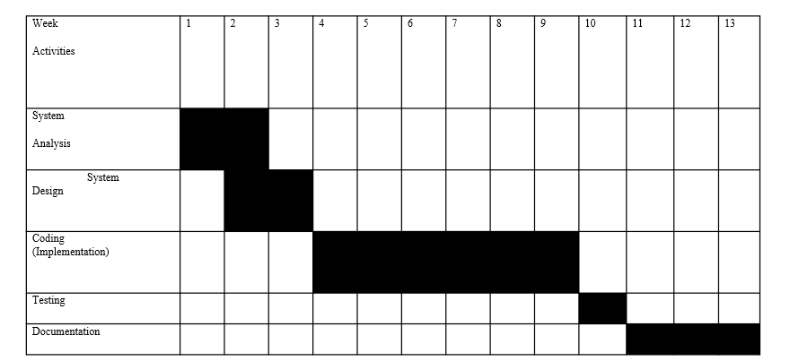

Figure 14: Gant Chart

# Chapter 6: Appendix

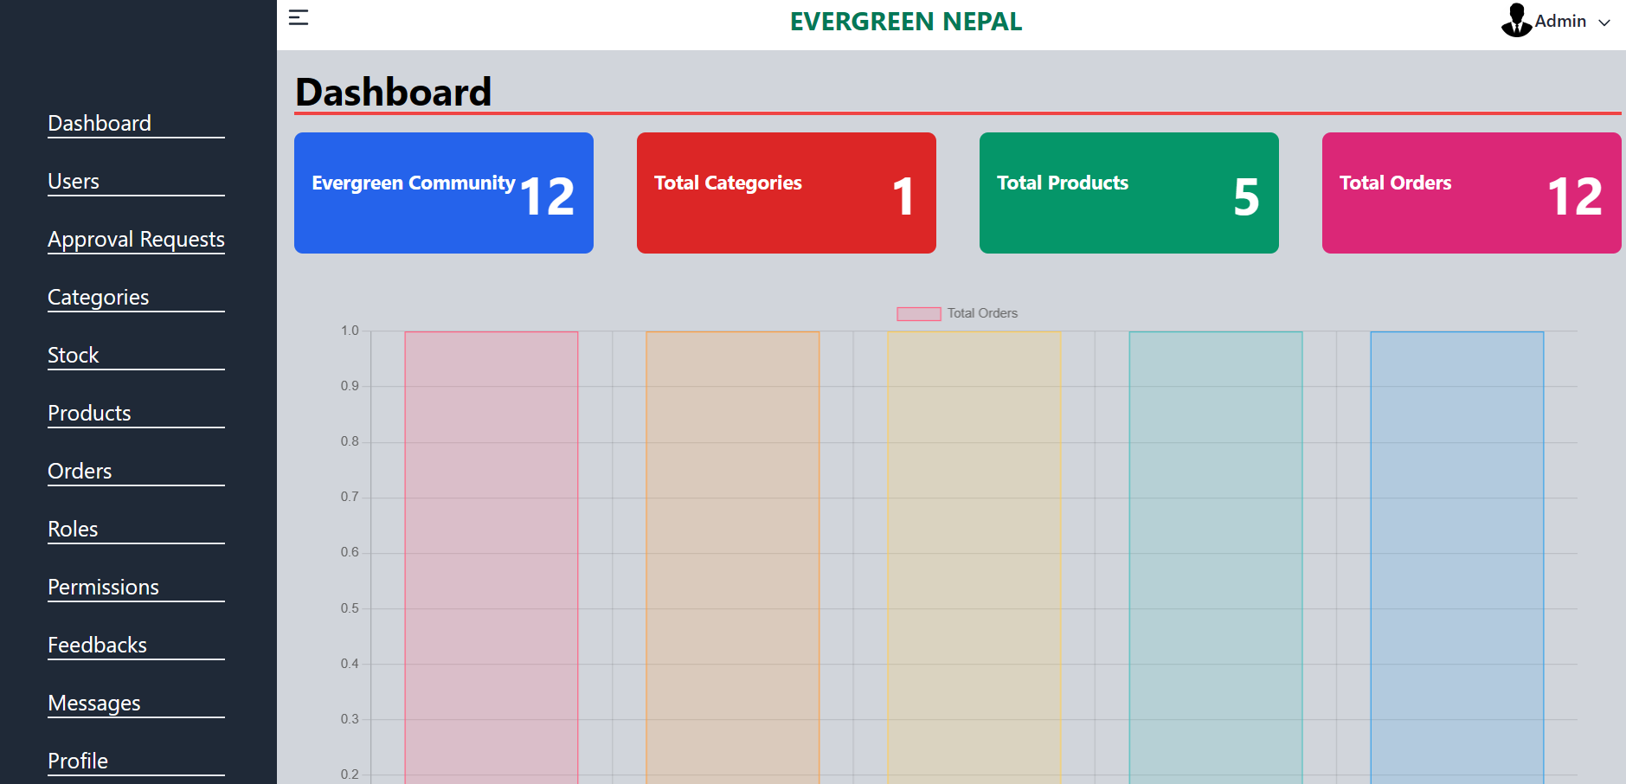

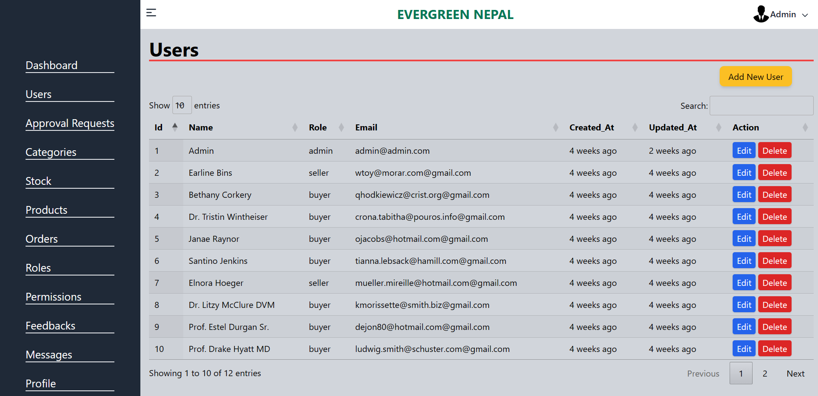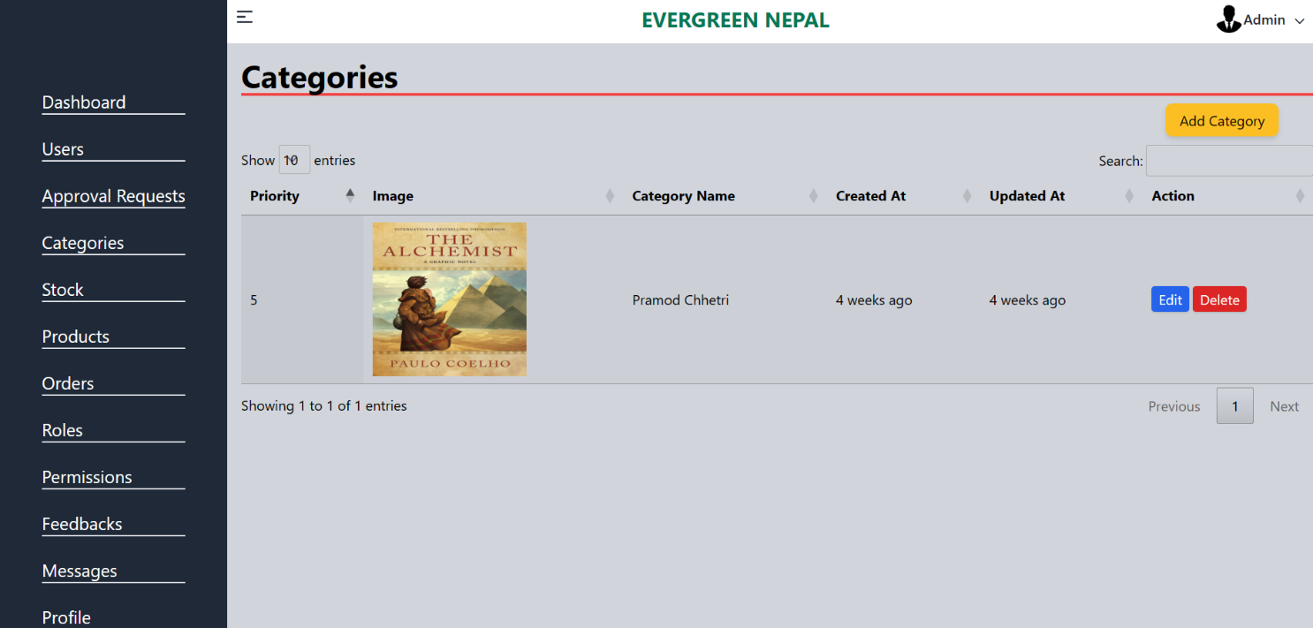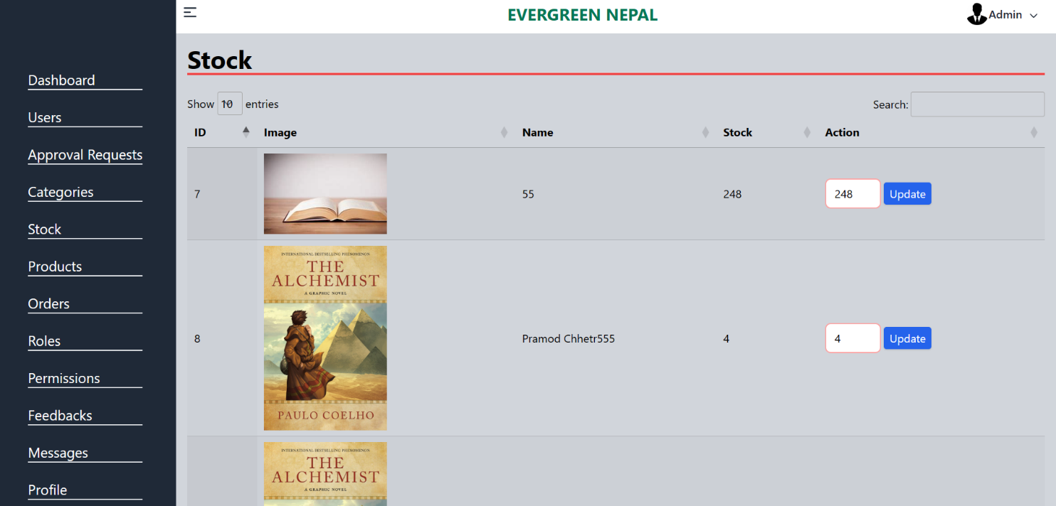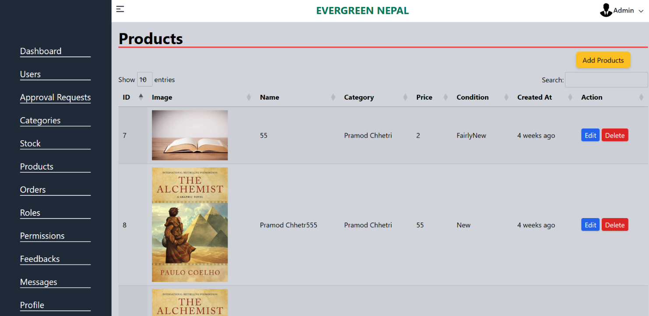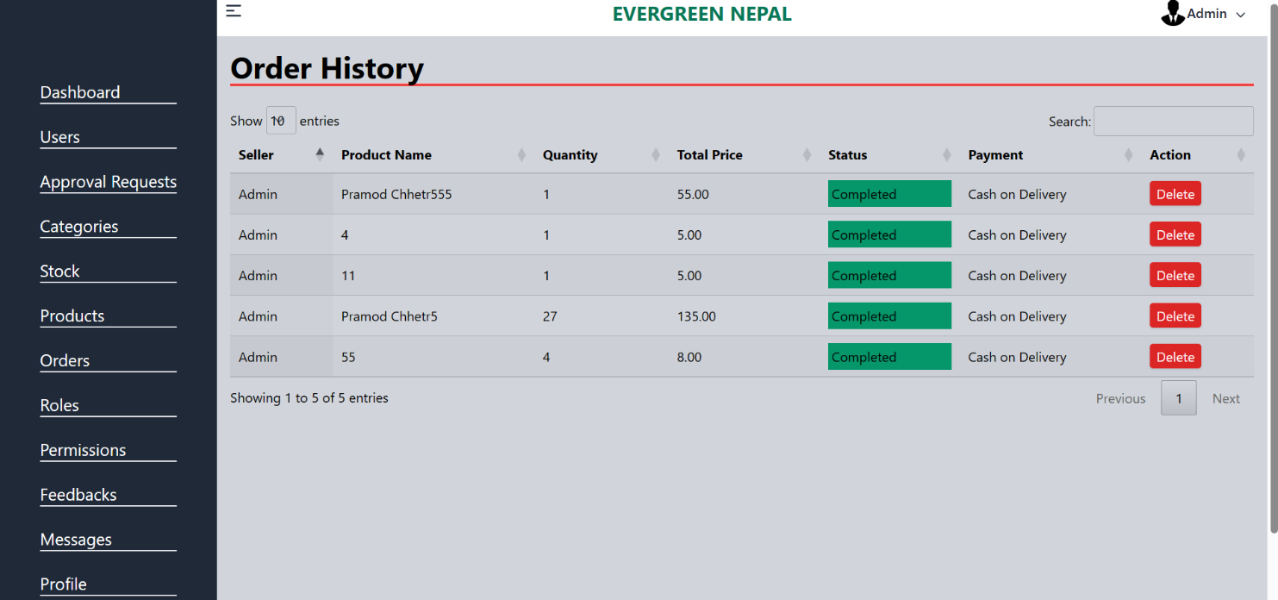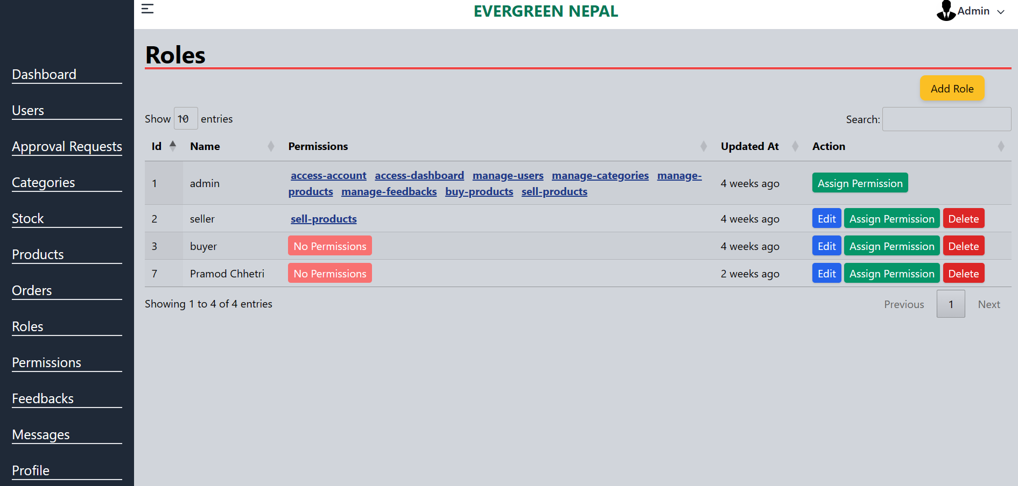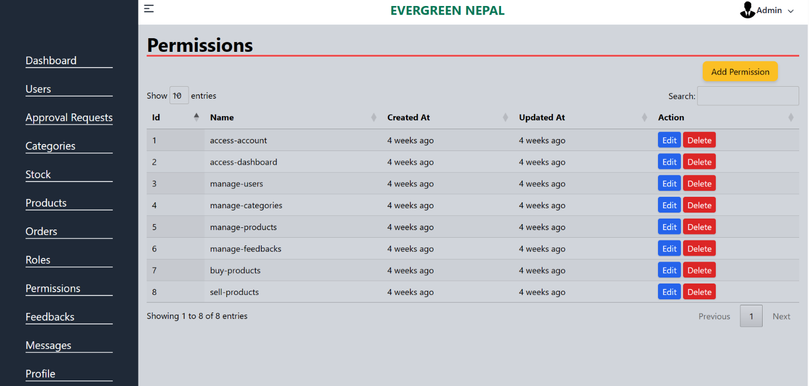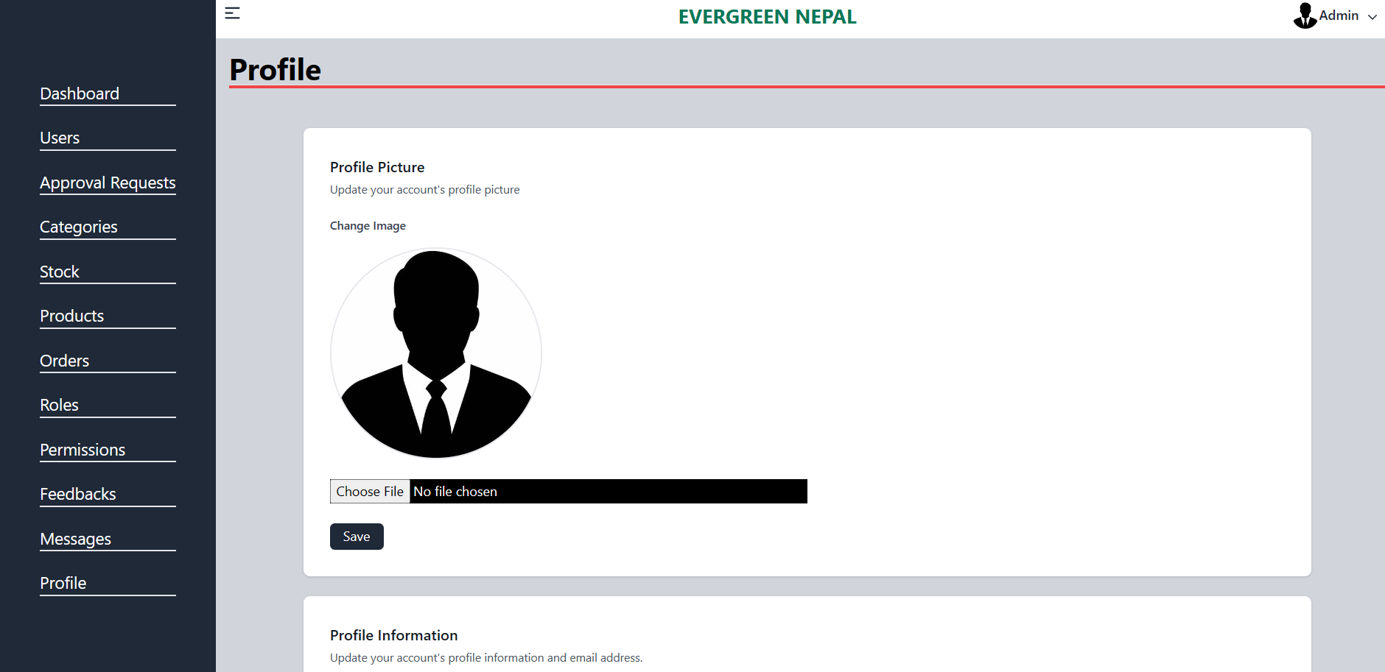

# References

[1] "Daraz Nepal - Online Shopping in Nepal," Daraz Nepal, 2022. [Online]. Available: https://www.daraz.com.np/. [Accessed: 06- Jun- 2022].

[2] "SastoDeal - Online Shopping in Nepal," SastoDeal, 2022. [Online]. Available: https://www.sastodeal.com/. [Accessed: 06- Jun- 2022].

[3] "HamroBazar - Sell & Buy Online in Nepal," HamroBazar, 2022. [Online]. Available: https://hamrobazar.com/. [Accessed: 06- Jun- 2022].

[4] "Mero Shopping - Online Shopping in Nepal," Mero Shopping, 2022. [Online]. Available: https://www.meroshopping.com/. [Accessed: 06- Jun- 2022].

[5] "OkDam - Online Shopping in Nepal," OkDam, 2022. [Online]. Available: https://www.okdam.com/. [Accessed: 06- Jun- 2022].

[6] "NepBay - Online Shopping in Nepal," NepBay, 2022. [Online]. Available: https://nepbay.com/. [Accessed: 06- Jun- 2022].